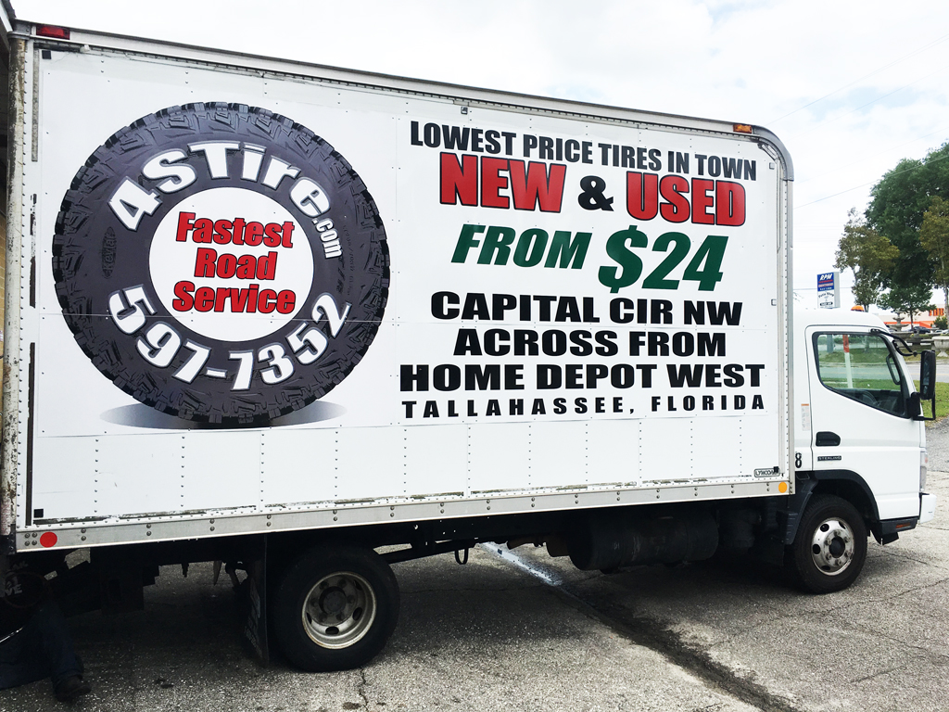

Please follow these easy
Steps to help us serve you even faster:
When you call for help to repair your vehicle tire, you will be asked the following questions. Please have the answers ready before calling 850-597-7352:

1- How can we help you?
2- What type of vehicle are you driving?
3- Have you checked your spare tire to make sure it is
ready to use?
4- What is the size of the damaged tire? There are located on
The side of the tire, above the rim. # # #/ # # R # #
5- What is the best phone number to call you back?
6- How far are you from our location, 1471 Capital Circle N.W. Tallahassee Fl?
7- Do you want NEW or PREMIUM USED Tire if available?
8- What is your CREDIT or DEBIT CARD number?
No cash or check will be accepted by the 24/7 Mobile Road Service

For security proposes, our Service Trucks are fully equipped with: LIVE VEDIO RECORDING SECURITY CAMERA & GPS LOCATOR DEVICE

Please click on 24/7 MOBILE ROAD SERVICE & read all
the related information, agreement, policies & service costs before calling & placing a service order. When ready, click bellow:

I am driving a passenger vehicle
I am a Semi Truck driver
Thank you & see you soon

