SEMIS & RVs
850-597-7352

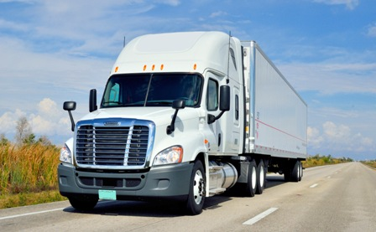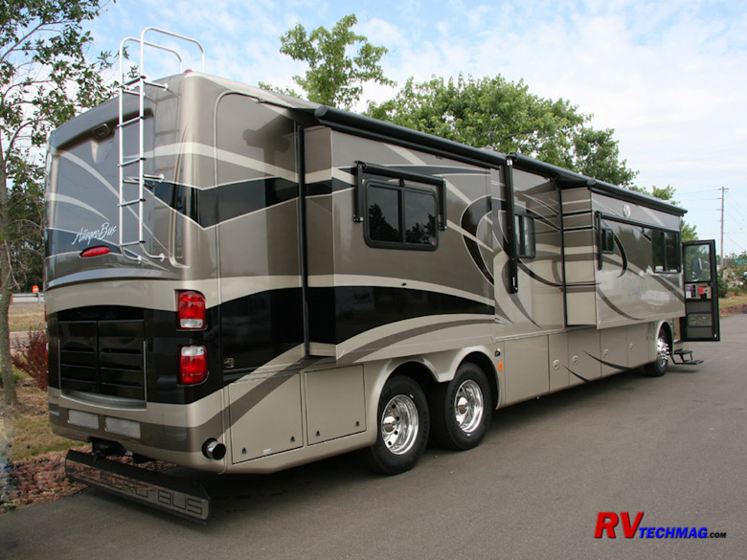

NORTH FLORIDA FASTEST 24/7 TIRE ROAD SERVICE FOR
With 24/7 access to tires
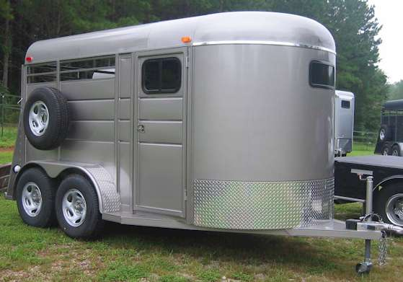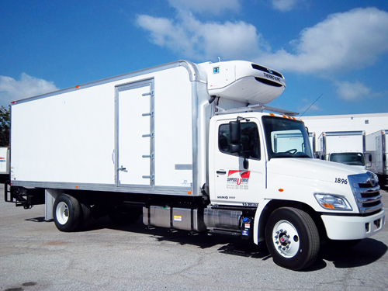

PRO MEN MOBILE ROAD SERVICE IS THE TRUCKERS
#1 TIRE REPAIR CHOICE IN NORTH FLORIDA !
850-597-7352
At $65 per tire mount & NO service fee,
Why call others & pay more?
PRO MEN TIRE ROAD SERVICE IS JUST A PHONE CALL AWAY
For a complete tire prices & service costs
Please click here
Truckers & RV drivers shouldn’t pay an arm & a leg for tires & repairs
When we offer the same at a much lower prices & faster service
